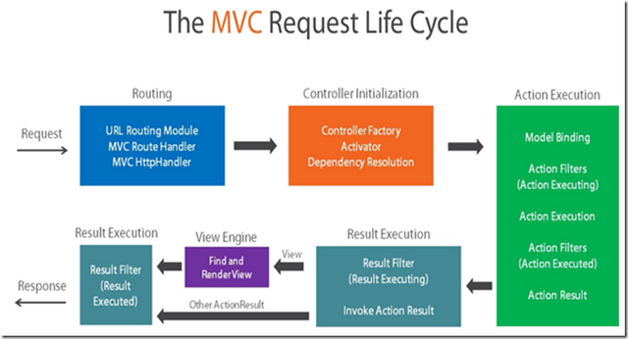

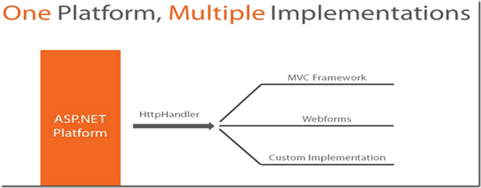

**Register Routes**

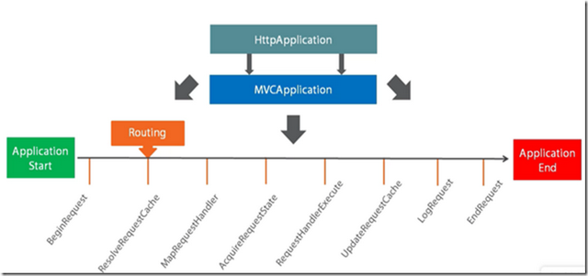

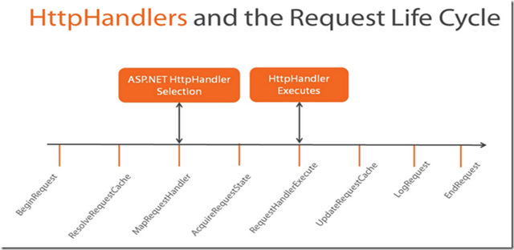

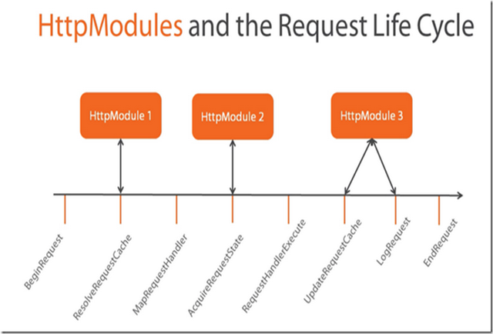

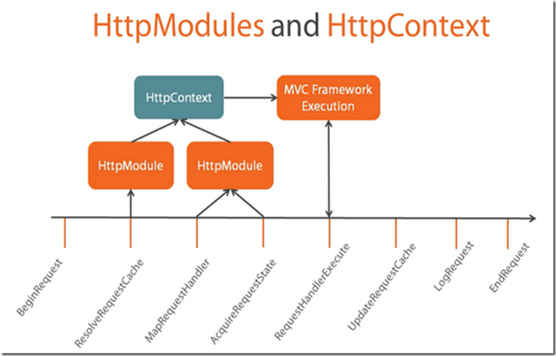

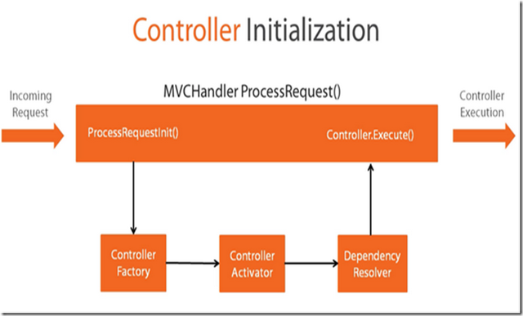

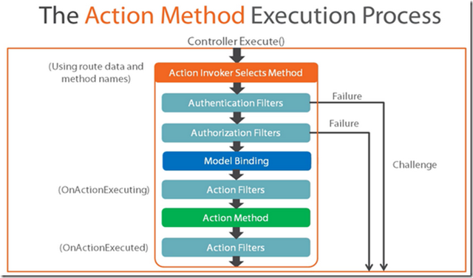

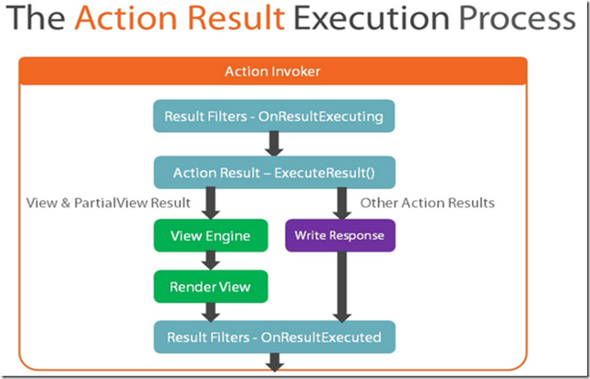

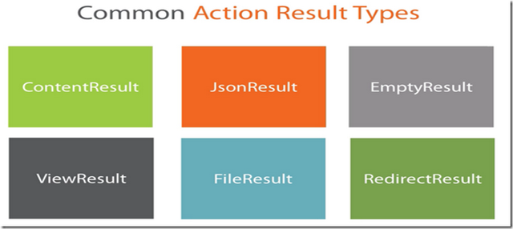

|  |  |  |
| --- | --- | --- |
| **Action Result** | **Helper Method** | **Description** |
| [ViewResult](https://msdn.microsoft.com/en-us/library/system.web.mvc.viewresult(v=vs.100).aspx) | [View](https://msdn.microsoft.com/en-us/library/system.web.mvc.controller.view(v=vs.100).aspx) | Renders a view as a Web page. |
| [PartialViewResult](https://msdn.microsoft.com/en-us/library/system.web.mvc.partialviewresult(v=vs.100).aspx) | [PartialView](https://msdn.microsoft.com/en-us/library/system.web.mvc.controller.partialview(v=vs.100).aspx) | Renders a partial view, which defines a section of a view that can be rendered inside another view. |
| [RedirectResult](https://msdn.microsoft.com/en-us/library/system.web.mvc.redirectresult(v=vs.100).aspx) | [Redirect](https://msdn.microsoft.com/en-us/library/dd492671(v=vs.100).aspx) | Redirects to another action method by using its URL. |
| [RedirectToRouteResult](https://msdn.microsoft.com/en-us/library/system.web.mvc.redirecttorouteresult(v=vs.100).aspx) | [RedirectToAction](https://msdn.microsoft.com/en-us/library/system.web.mvc.controller.redirecttoaction(v=vs.100).aspx)  [RedirectToRoute](https://msdn.microsoft.com/en-us/library/system.web.mvc.controller.redirecttoroute(v=vs.100).aspx) | Redirects to another action method. |
| [ContentResult](https://msdn.microsoft.com/en-us/library/system.web.mvc.contentresult(v=vs.100).aspx) | [Content](https://msdn.microsoft.com/en-us/library/system.web.mvc.controller.content(v=vs.100).aspx) | Returns a user-defined content type. |
| [JsonResult](https://msdn.microsoft.com/en-us/library/system.web.mvc.jsonresult(v=vs.100).aspx) | [Json](https://msdn.microsoft.com/en-us/library/system.web.mvc.controller.json(v=vs.100).aspx) | Returns a serialized JSON object. |
| [JavaScriptResult](https://msdn.microsoft.com/en-us/library/system.web.mvc.javascriptresult(v=vs.100).aspx) | [JavaScript](https://msdn.microsoft.com/en-us/library/dd505087(v=vs.100).aspx) | Returns a script that can be executed on the client. |
| [FileResult](https://msdn.microsoft.com/en-us/library/system.web.mvc.fileresult(v=vs.100).aspx) | [File](https://msdn.microsoft.com/en-us/library/system.web.mvc.controller.file(v=vs.100).aspx) | Returns binary output to write to the response. |
| [EmptyResult](https://msdn.microsoft.com/en-us/library/system.web.mvc.emptyresult(v=vs.100).aspx) | (None) | Represents a return value that is used if the action method must return a **null** result (void). |

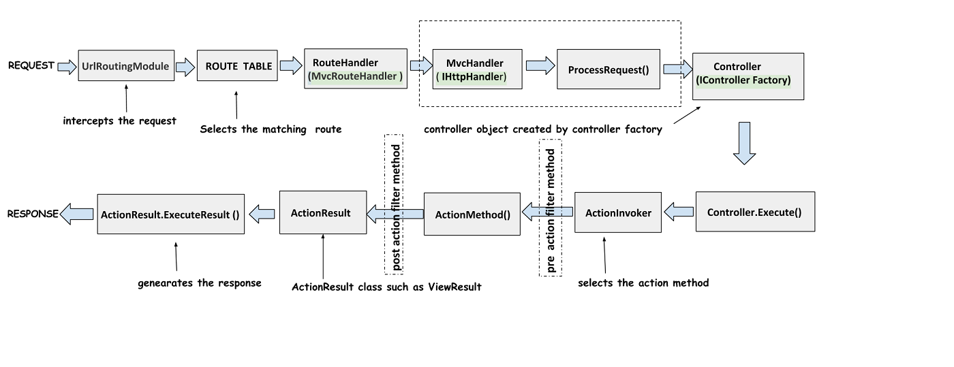

UrlRoutingModule

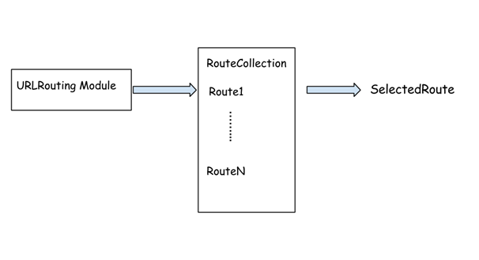

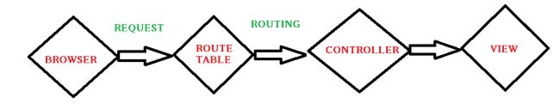

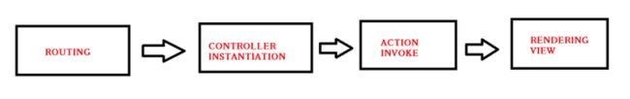

**The High-Level Request Routing Pipeline**

The Routing pipeline consists of the following high-level steps when a request is handled by ASP.NET:

1. The UrlRoutingModule attempts to match the current request with the routes registered in

the RouteTable.

2. If one of the routes in the RouteTable matches, the Routing module grabs the

IRouteHandler from that route.

The Routing module calls the GetHttpHandler method of the IRouteHandler, which

returns the IHttpHandler that will be used to process the request.

4. ProcessRequest is called on the HTTP handler, thus handing off the request to be handled.

5. In the case of ASP.NET MVC, the IRouteHandler is an instance of MvcRouteHandler,

which, in turn, returns an MvcHandler that implements IHttpHandler. The MvcHandler is

responsible for instantiating the controller, which, in turn, calls the action method on that

controller.